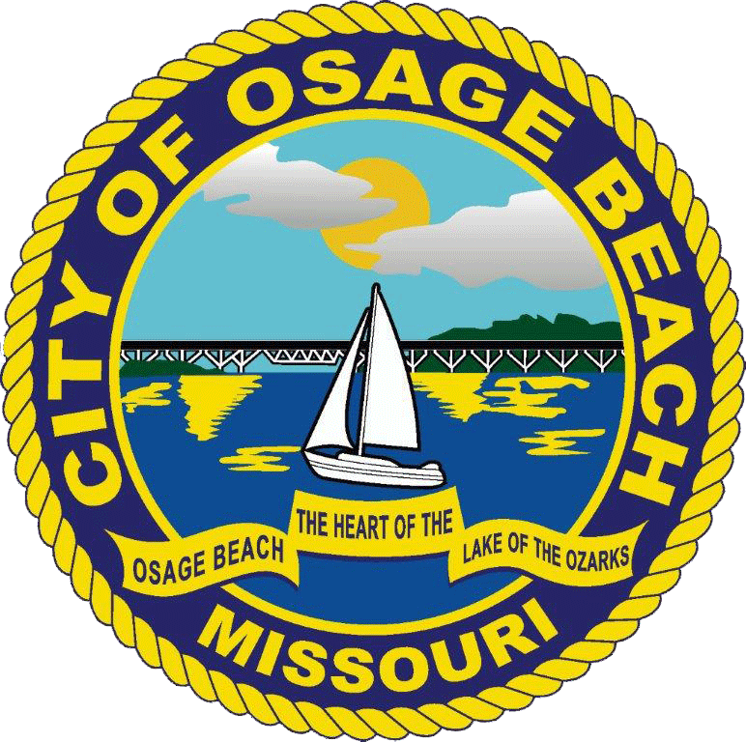

NEWS RELEASE

For Release: Immediate Release Contact: Michael O’Day
Administrative Lieutenant
City of Osage Beach
573.302.2010 x1101
moday@osagebeach.org

-City of Osage Beach-

WEEKLY SUMMARY
February 08, 2021 – February 14, 2021

911 Hang Ups 1
Accident 11
Alarm 22
Ambulance 5
Animal Control 1
Assault 1
Building/Area Check 32
Check the Welfare 1
Citizens Assist 4
Court 2
Disturbance 4
Fingerprinting 2
Fire 1
Follow Up 14
Fraud 3
Jakes Law Check 1
Keep the Peace 3
Lockout 1
Motorist/Assist 8
Mutual Aid 1
Other Agency Assist 3
Pedestrian Check 2
Property Lost 1
Property Damage 3
Robbery 1
Shots Fired 1
Special Detail 1
Stealing 8
Suspicious Activity 3
Traffic Control 2
Traffic Hazard 3
Traffic Stop 1
Vacation Check 1
Vehicle Check 6
Warrant Service 4

ARRESTS

02-08-2021 – w/f age 34 from Osage Beach, MO – Freddie L. Karnes – Driving While Intoxicated – Prior Offender, Accident – Injury, Operate MV Without Maintaining Financial Responsibility (MV Required to be Registered) – 1st Offense, Operate MV in a Careless and Imprudent Manner – Involving an Accident

02-09-2021 – w/f age 25 from Olean, MO – Krista Nichole Faigle – Warrant – Fail to Appear – Municipal

02-10-2021 – w/m age 23 from Camdenton, MO – Griffin Lee Eidson – Possess Marijuana/Synthetic Cannabinoid of 10 Grams or Less, Unlawful Possession of a Firearm, Unlawful Possession of Drug Paraphernalia

02-10-2021 – w/m age 23 from Camdenton, MO – Skylar Reeves – Warrant – Fail to Appear – Municipal

02-12-2021 – w/f age 19 from Linn, MO – Macy Emma Nolte – Warrant – Other Agency

02-12-2021 – w/m age 19 from Jefferson City, MO – Timothy Lee Todd – Stealing - $750 or More, Warrant – Other Agency

02-12-2021 – w/m age 30 from Osage Beach, MO – Nicholas Shane Ruebling – Warrant – Other Agency, Warrant – Fail to Appear – Municipal, Warrant – Other Agency

Never miss any information from the City of Osage Beach; sign up for all City alerts at www.osagebeach.org. Click on the “Notify Me Sign Up” and follow the easy steps.

